Light, Land & Country
March 9 – April 3, 2018
Gallery 23
23 Atholl Crescent
Edinburgh, EH3 8HQ
Tel. (0131) 229 1528

The depiction of the natural world has fascinated artists since prehistoric times. Greek and Romans artists often depicted elaborate wall paintings of landscapes and gardenscapes in pleasure villas. In China’s late Tang dynasty, landscape painting had evolved into an independent genre that embodied a universal longing by the elite to commune with nature. However, the term "landscape" didn’t come into general use until the 1600s. Derived from the Dutch term landschap--meaning a region or tract of land--it gradually developed into a popular genre in seventeenth-century Holland for wealthy Calvinist patrons who desired paintings that described the beauty and spirituality of the world around them. By the second half of the 20th century, the concept of landscape was extended to incorporate concepts of urban architecture and the rise of industrial spaces. Likewise the rise of nature photography has been used to document issues of conservation, environmentalism, and concerns of land use.

For our Spring 2018 exhibition, Gallery 23 welcomes artists of any medium to submit works that invite viewers to contemplate the ways in which we relate to the land we inhabit and explore the ways we relate to our own physical environment. We encourage submissions in ANY two-dimensional artistic medium, as well as multiple prints or copies of photographs. Works are not limited to solely to the visual; we are open to text-based works as well.

All works will be for sale at the artist’s discretion.

For more information about Gallery 23 please visit:
https://www.facebook.com/Gallery23/?fref=ts
-----------------------------------------------------------------------------------------
Submission Guidelines:
Please send either a preliminary sketch or an image of a completed work to both:

Dr. Julie V. Hansen Laura Ridlon
Gallery Director Intern
gallery@esuscotland.org.uk s1736175@sms.ed.ac.uk

Submission Deadline: February 7, 2018

Feel free to submit existing work that you feel is congruous with the intentions of this project.
For more information about visit: https://www.facebook.com/Gallery23/?fref=ts

DROP OFF: Monday, March 5 – Wednesday, March 7, or by special appointment) Please ensure all work is signed, has all info on reverse and is display ready. If framed, we prefer white or neutral frames.

Please Include The Following in Your Submission:
• Up to 10 images of your artwork with titles
• Title format: FULLNAME_TITLE_SIZE_MEDIUM_DATE_PRICE/RANGE (for multiples, please specify the edition: ie.“digital print, edition of 10”)
• A brief artist bio/statement up to 200 words with any pertinent information related to works submitted for label or catalogue copy
• Contact information including phone number/email / *website / *blog / *instagram (*if applicable)

COMMISSION: Gallery 23 will accept a 30% commission of any sales of consigned artwork during the exhibition period.

PICK UP: Unsold works will be available Wednesday, April 4th for pick up.

The exhibition opening will be held at the gallery’s West End location on Friday, March 9th, from 6:30-9:30.

EMAIL: gallery@esuscotland.org.uk
WEBSITE: https://gallery23.org.uk/
FACEBOOK: https://www.facebook.com/Gallery23/
Hours: Monday, Wednesday, Thursday and Friday 12.00 / 5.00 p.m. | Saturday 12.00 p.m./ 4.00 p.m.
-------------------------------------------------------------------------------------------------------------------

ART SUPPORTING A CHARITABLE CAUSE
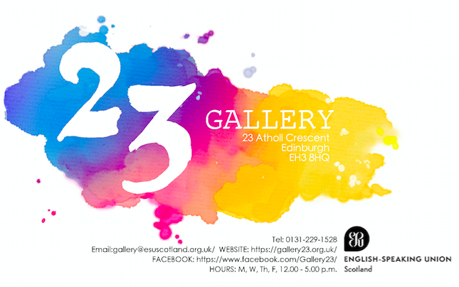

Gallery 23 is affiliated with ESU Scotland (English Speaking Union), an international charity recognised for its schools’ educational programmes. All proceeds from art sales support the charity.

To become a member of Gallery 23, please contact: secretary@esuscotland.org.uk

