Gwen Hardie : Earthly Bodies

In conversation with Gallery 23 director, Dr. Julie Hansen
Artist Talk: Thursday, July 26, 2018, 18:30-20:30

Gallery 23
23 Atholl Crescent
Edinburgh, EH3 8HQ Tel. (0131) 229 1528

Born and educated in Scotland, painter Gwen Hardie lived and worked in London and Berlin (studying with Georg Baselitz) before settling permanently in New York City in 2000. Her work appears in numerous private and public art collections throughout Europe and the U.S., and she is the youngest living artist ever to be given a solo show at The Scottish National Gallery of Modern Art in Edinburgh. A member of a talented and high profile Scottish arts family, Hardie’s monumental ‘skin portraits’ are illusionistic 3D paintings depicted in the Classic tondo (circular format) that was popularized during the Italian Renaissance. Simultaneously engaging themes of the microcosm and the universal, Hardie’s works are often magnified to the point of abstraction.
Focusing her intense gaze on skin and bodily surface, Hardie probes the surface details of our bodies in light and shadow, revealing truths inherent in both our physical and psychological selves.

Please join Gallery 23 for a very special evening in conversation with Gwen Hardie. Free.

ART SUPPORTING A CHARITABLE CAUSE
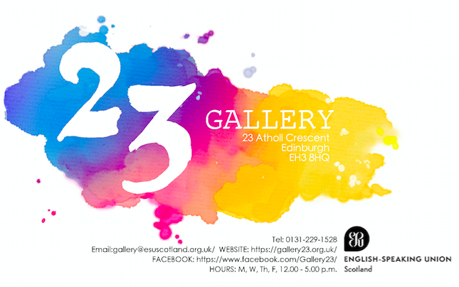

EMAIL: gallery@esuscotland.org.uk/WEBSITE: https://gallery23.org.uk/
FACEBOOK: https://www.facebook.com/Gallery23/ Hours: M, T, W, T, F 12.00 / 5.00 p.m.

Gallery 23 is affiliated with ESU Scotland (English Speaking Union), an international charity recognised for its schools’ educational programmes. All proceeds from art sales support the charity.
To become a member of Gallery 23, please contact: secretary@esuscotland.org.uk

